**ELASTIC LOAD BALANCER STICKY SESSIONS**

It is possible to impelement stickiness so that the same client is always redirected to the same instance behind the load balancer ad it is done with help of a cookie which the client send to the load balancer.

Disadvantage:

The disadvantage is that there may be an imbalance to the load over the backend ec2 instances as all the load may be send to one instance etc.

**TYPES OF COOKIES**

**1.APPLICATION BSED COOKIES:**these are the cookies that are generated by the application only and the duration is specified by the application only.

**2.DURATION BASED COOKIES:**

In the duration based cookie a duration is set by the load balancer itself for the session.

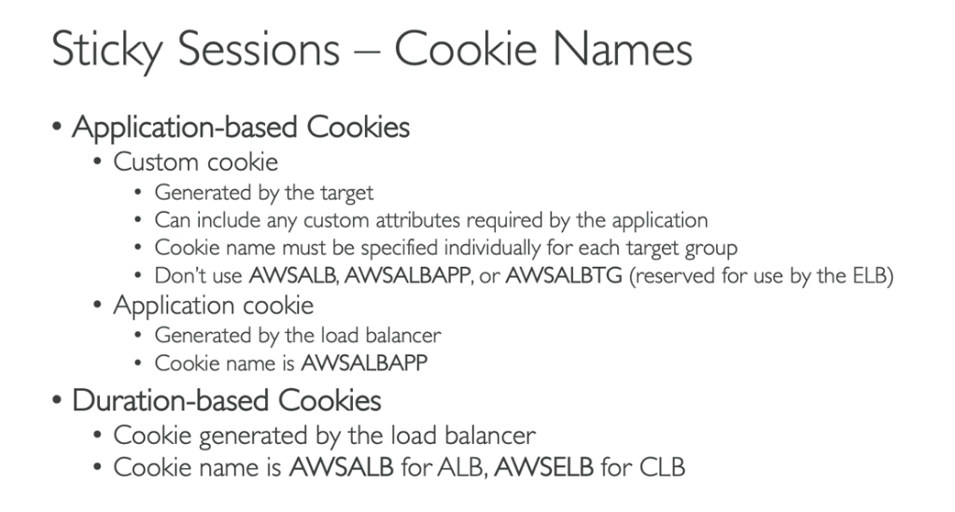

**HOW TO ENABLE STICKINESS**

1.go to target group lvele and from there go to actions and attributes.

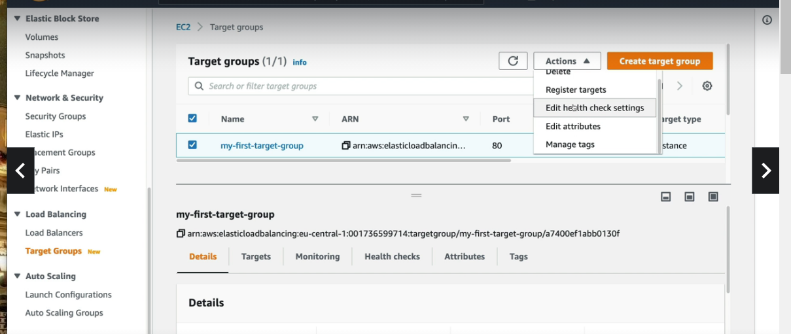

2.Now tick stickiness

We can check for cookie in network tab

There is a cookie there you go to the session.